**OMM500N - Assignment 1 – Problem 1**

**Upgrading a Fleet of School Buses**

**Part One. Background**

St.Louis city wants to upgrade their school bus with some constraints, and we’re gonna maximize the result under this circumanstance.

**Part Two. Problem Statement**

1. **Assumptions**

One driver per car -> maximum 450 drivers -> 450 cars

best use of the allocation’ -> maximize seating capacity with new type buses

1. **Variables**

Xa – new type A’s amount

Xc – new type C’s amount

Xold – old buses

1. **Objective Function**

Max 50*Xc + 25*Xa + 0*Xold

1. **Constriants**

Money: 70000*Xc + 50000*Xa <= 10 millions

AFE: (8*Xc + 10*Xa + 5*Xold ) >= 6*( Xc+Xa+Xold)

Driver amounts: Xa + Xc + Xold <= 450

Old buses amount: Xold <= 400

Total seating capacity: 50*Xc + 25* Xa + 50* Xold >= 20000

Non-negativity

**4) Solver:**

Linear or Nonlinear solver can both complete the work.

**Part Three. Result and Recommendation**

1. **Result**

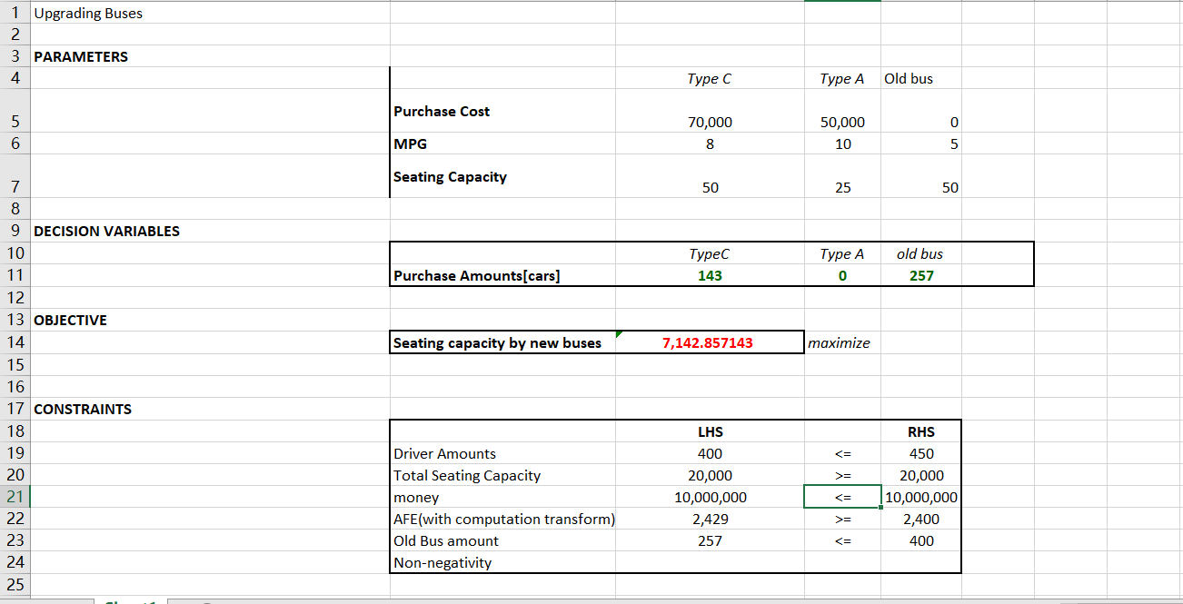

Buying 143 new type C, and retain 257 old buses, this can provide 7142 seats under upgraded buses and satisfying all constraints.

1. **Recommendation:**

Budget is not enough for all students to have themselves in new buses.

Under this circumstance, new Type C bus is much preferred than new Type A bus.